**Lab 3**

**Question:**

This problem presents a two-stage banking model with two processes in series. Customers arrive at a booth with exponentially distributed inter-arrival times of mean 8 minutes. And the customer has to wait in a queue 3-to-6 minutes uniformly. Now when a new customer comes to the booth, he/she see the queue. If he/she feels comfortable then he/she wait before the queue. 70% customers are waited before the queue and remains will check the line after some. After enter in a booth each customer needs 2 minutes for each to complete his/her works.

We are interested in simulating the system for 12 hours to obtain process utilizations.

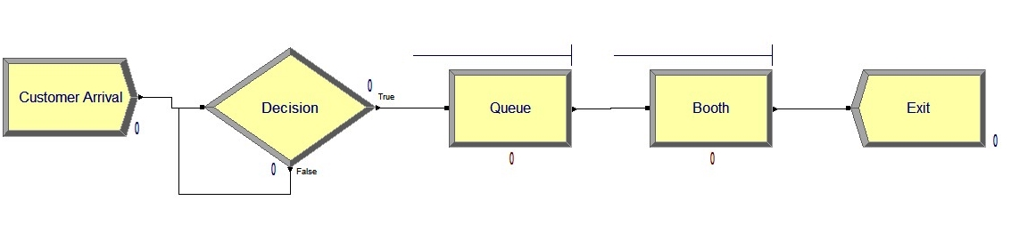

**Diagram:**

After Simulation

